OUM

IM.090  Migration Instructions

BI ETL Release 2B

Author: Raghav/Supriya

Creation Date: Feb 01,2017

Last Updated: Feb 01,2017

Document Ref:

Version: 1.0

1. **Title, Subject, Last Updated Date, Reference Number**, **and** **Version** are marked by a Word Bookmark so that they can be easily reproduced in the header and footer of documents. When you change any of these values, be careful not to accidentally delete the bookmark. **You can make bookmarks visible by selecting the Office Button>Word Options>Advanced> and checking the Show bookmarks option in the Show document content region.**

**Approvals:**

|  |  |
| --- | --- |
| Vinay Pachika |  |
| Viswam Nair |  |

1. **Title, Subject, Last Updated Date, Reference Number**, **and** **Version** are marked by a Word Bookmark so that they can be easily reproduced in the header and footer of documents. When you change any of these values, be careful not to accidentally delete the bookmark. **You can make bookmarks visible by selecting the Office Button>Word Options>Advanced> and checking the Show bookmarks option in the Show document content region.**
2. To add additional approval lines, press [Tab] from the last cell in the table above.
3. You can delete any elements of this cover page that you do not need for your document.

# Document Control

## Change Record

40

| Date | Author | Version | Change Reference |
| --- | --- | --- | --- |
|  |  |  |  |
|  |  |  |  |

## Reviewers

| Name | Position |
| --- | --- |
|  |  |
|  |  |
|  |  |
|  |  |

Contents

1 Document Control 2

1.1 Change Record 2

1.2 Reviewers 2

2 Installation Instructions for Code Migration 5

2.1 Pre-Migration Steps 5

3 Migration Steps for P3 Performance Improvement, Reprocessing logic for P1,P2 & P3 and moving of remaing views to custom schema 6

3.1.1 Transfer Database scripts to Target SVN repository 6

3.1.2 Transfer Database scripts to Target SVN repository - EBS 6

3.1.3 Transfer ODI packages to Target SVN Repository 6

3.1.4 Import ODI code components into Target instance 7

3.1.5 Re-generate the Custom ODI Packages 9

Note: When re-generating the senario’s , please ignore scenario variables(ie., no need to select all/specific parameters, leave as is.) Just click on OK to complete the scenario re-generation process. 10

3.1.6 Verification Checklist 11

4 Migration Steps for NBV patch fix as per Oracle SR# 3-13636057311 12

4.1.1 Transfer Database scripts to Target SVN repository 12

4.1.2 Transfer Database scripts to Target SVN repository - EBS 12

4.1.3 Transfer ODI packages to Target SVN Repository 12

4.1.4 Import ODI code components into Target instance 13

4.1.5 Re-generate the Custom ODI Packages 15

Note: When re-generating the senario’s , please ignore scenario variables(ie., no need to select all/specific parameters, leave as is.) Just click on OK to complete the scenario re-generation process. 16

4.1.6 Verification Checklist 17

5 Re-Generate Load Plan in the Target instance 18

5.1 Execute Load Plan in the Target instance 19

6 Open and Closed Issues 21

6.1 Open Issues 21

6.2 Closed Issues 21

1. To update the table of contents, put the cursor anywhere in the table and press [F9]. To change the number of levels displayed, select the menu option Insert‑>Index and Tables, make sure the Table of Contents tab is active, and change the Number of Levels to a new value.

# Installation Instructions for Code Migration

|  |  |
| --- | --- |
| **Source Environment Name:** UAT | **Machine:** TCGI13 |

|  |  |
| --- | --- |
| **Target Environment Name:** PROD | **Machine:** PCGIT3 |

## Pre-Migration Steps

* Login to the ODI studio and apply the <Target> Environment Repository Connection Information and ensure you are able to connect to the Repository with the given user credentials
* Export the ODI Topology of the Target Instance for the backup for the very first time migration

Goto> ODI Studio client> Topology Navigator > click on Connect Navigator > Export > Select Export the Topology> Save it on your local (backup)

* Able to access the ODI Enterprise Configuration manager application with the user credentials
* Ensure the credentials are ready with the Source database and Target Datawarehouse environment details being migrated
* Take the ODIREPO schema database backup of the target instance if the load is executed for the very first time in the target instance.
* Drop all the temp tables in the Target instance by running the below query

SELECT Table_Name, Num_Rows

FROM All_Tables

WHERE (Table_Name LIKE 'C$%'

        OR Table_Name LIKE 'I$%')

      AND Num_Rows > 0

ORDER BY Num_Rows DESC;

* Once the import is successful without any errors/warnings, save the changes.
* When ever we generate a new Load plan , make sure to add the exception email ODI alert scenario.
* **NOTE**: Please capture all the deployment successful screen shots for DEV team reference

# Migration Steps for P3 Performance Improvement, Reprocessing logic for P1,P2 & P3 and moving of remaing views to custom schema

### Transfer Database scripts to Target SVN repository

**NOTE:** Ensure the SVN update is complete before downloading the files from the SVN

* Copy below table creation scripts from Source SVN repository to target repository

SVN Base Path: http://subversion.sys.cigna.com/svn/ORACLE_BI_REPO

Source Location: <Source_MAIN\DBScripts\Tables\Release 2

Target Location : <Target>_MAIN\DBScripts \Tables\

#### Execute scripts in the database-DW Schema(DBA)

|  |  |  |  |  |  |  |
| --- | --- | --- | --- | --- | --- | --- |
| **Script #** | **Dev Version #** | **TS Version#** | **CRP1 Version#** | **UAT Version#** | **PROD Version#** | **File Name** |
| 1 |  |  |  |  |  | .sql |

* Do Commit

### Transfer Database scripts to Target SVN repository - EBS

**NOTE:** Ensure the SVN update is complete before downloading the files from the SVN

* Copy below table creation scripts from Source SVN repository to target repository

SVN Base Path: http://subversion.sys.cigna.com/svn/BFF

Source Location: <Source>\BFF_SVN\Branches\BI\admin\sql\views

Target Location: <Target>\BFF_SVN\Branches\BI\admin\sql\views

#### Execute scripts in the database(EBS) (DBA)

|  |  |  |  |  |  |  |  |
| --- | --- | --- | --- | --- | --- | --- | --- |
| SL No | STAT CSR | Archive Set# | Dependency | Instances | Description | File Name |  |
| 1. | 916 | 2,3 |  | DEV/TS/UAT/PROD | Creates Apps schema objects |  |  |

### Transfer Database scripts to Target SVN repository - EBS

**NOTE:** Ensure the SVN update is complete before downloading the files from the SVN

* Copy below table creation scripts from Source SVN repository to target repository

SVN Base Path: http://subversion.sys.cigna.com/svn/BFF

Source Location: <Source>\BFF_SVN\Branches\BI\admin\sql\tables

Target Location: <Target>\BFF_SVN\Branches\BI\admin\sql\tables

#### Execute scripts in the database(EBS) (DBA)

|  |  |  |  |  |  |  |  |
| --- | --- | --- | --- | --- | --- | --- | --- |
| SL No | STAT CSR | Archive Set# | Dependency | Instances | Description | File Name |  |
| 1. | 916 | 4 |  | DEV/TS/UAT | Drop tables in xxc schema. This is required till UAT. |  |  |

|  |  |  |  |  |  |  |  |
| --- | --- | --- | --- | --- | --- | --- | --- |
| SL No | STAT CSR | Archive Set# | Dependency | Instances | Description | File Name |  |
| 1. | 916 | 5 |  | DEV/TS/UAT/PROD | Creates tables in xxc schema objects |  |  |

### Transfer ODI packages to Target SVN Repository

* Copy below ODI objects from Source SVN repository to target repository

SVN Base Path: <http://subversion.sys.cigna.com/svn/ORACLE_BI_REPO>

Source Location: UAT_MAIN/ODI/Custom/Release 2B

Target Location : <Target>_MAIN\ODI\

|  |  |  |  |  |  |  |
| --- | --- | --- | --- | --- | --- | --- |
| **Script #** | **Dev Version #** | **TS Version#** | **CRP1 Version#** | **UAT Version#** | **PROD Version#** | **File Name** |
| 1. | 1451 | 1451 |  | 1450 |  | SDE_WC_P3_Stage_SubLedgerPrealloacExpenseFact.zip |
| 2. | 1402 | 1404 |  | 1456 |  | SIL_WC_P1_PreallocExpenseFact.zip |
| 3. | 1402 | 1404 |  | 822 |  | SIL_WC_P2_NONFAHPreallocExpenseFact.zip |
| 4. | 1402 | 1404 |  | 1456 |  | SIL_WC_P3_SubLedgerPrealloacExpenseFact.zip |
| 5. | 1402 | 1404 |  | 1456 |  | SIL_FINAL_LOAD_WC_PREALLOC_EXP_F.zip |

* Do SVN Commit

### Import ODI code components into Target instance

* Log into ODI Studio with a user as bi apps administrator.
* Import ODI objects into the target instance as shown in the screen shot below.
* Desginer Navigation: Go to Projects 🡪 click on Connect Navigator --> Select Import

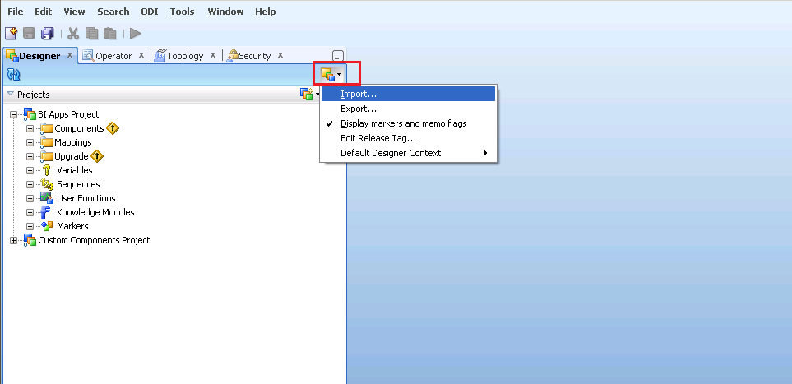

* Select the option Smart Import and then clieck Ok

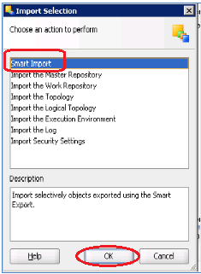

* Browse and Select the ZIP files downloaded from SVN listed below: (Only one file can be selected at a time)



* **Note**: At the Import Actions step, Goto Topology Section--> Select each component beneath it and mark the Action = Ignore from the dropdown values (this applies for only Topology,else ignore this Topology section)

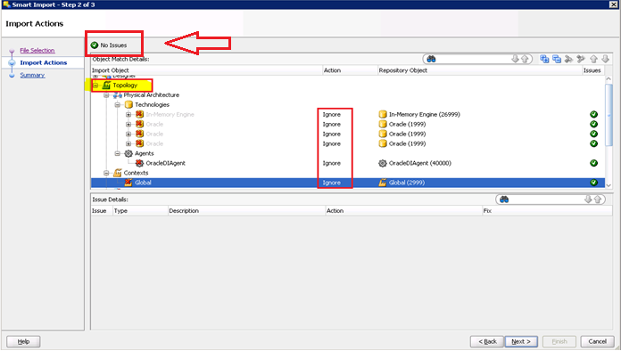

* Check if any errrors on the top, if No Issues displayed then Click Next
* Complete importing every file listed below by following the above steps sequence. Save the log and send to dev team if errors are encountered.

NOTE:

1. You can ignore/overwrite the OOB table(W_%) errors shown while importing any of the above packages

2) In case if you get nullpointer exception, as shown in the below screenshot, Please delete that particular code component from the repository and then follow the above mentioned steps to import the code.

e.g: Screenshot for Nullpointer exception:

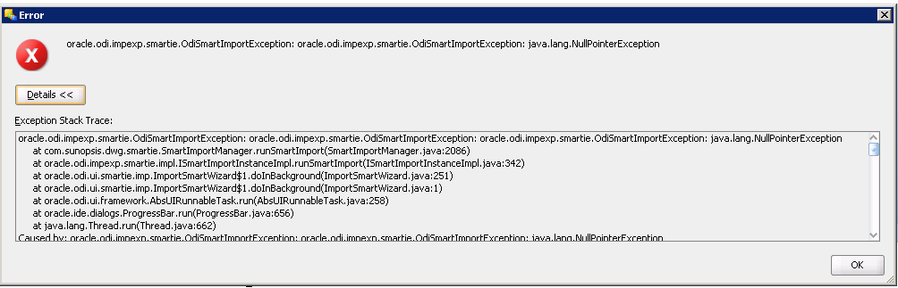

### Re-generate the Custom ODI Packages

* Regenerate the below Custom package scenarios

Desginer : Goto Projects > BI Apps Project > Mappings > CUSTOM_SDE_Adaptor>File Name>Packages>Scenarios >Right click Re-generate

& CUSTOM_SILOS>File Name>Packages>Scenarios >Right click Re-generate

| Script # | File Name |
| --- | --- |
|  | SDE_WC_P3_Stage_SubLedgerPrealloacExpenseFact |
|  | SIL_WC_P1_PreallocExpenseFact |
|  | SIL_WC_P2_NONFAHPreallocExpenseFact |
|  | SIL_WC_P3_SubLedgerPrealloacExpenseFact |
|  | SIL_FINAL_LOAD_WC_PREALLOC_EXP_F |
|  |  |

Example:

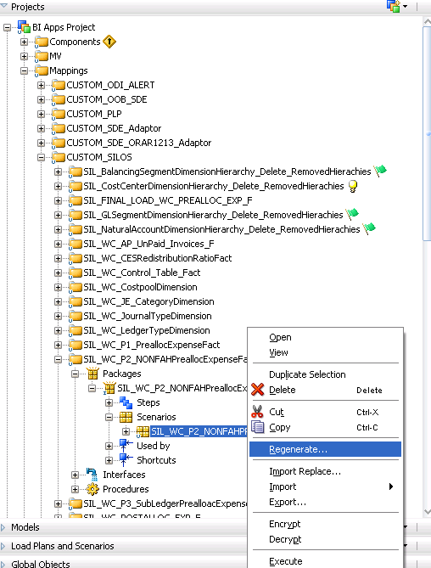

### Note: When re-generating the senario’s , please ignore scenario variables(ie., no need to select all/specific parameters, leave as is.) Just click on OK to complete the scenario re-generation process.

### Verification Checklist

1. Include a subset of test steps that will confirm that the customization has been installed properly.

Verify that the deployment has been completed successfully by following these steps:

After importing the above code into ODI, Check the new P3 code have below interfaces as shown below.

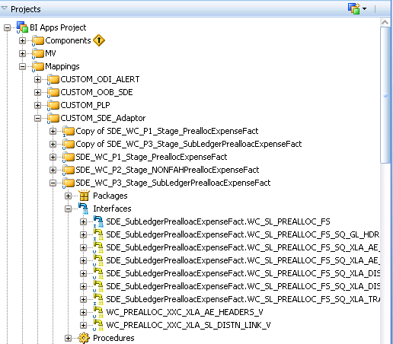

All the components in the ETL_Release_2B should be displayed, please do the following high level components in the ODI Studio, under the CUSTOM_SDE & Custom_SILOS.

|  |
| --- |
| SDE_WC_P3_Stage_SubLedgerPrealloacExpenseFact |
| SIL_WC_P1_PreallocExpenseFact |
| SIL_WC_P2_NONFAHPreallocExpenseFact |
| SIL_WC_P3_SubLedgerPrealloacExpenseFact |
| SIL_FINAL_LOAD_WC_PREALLOC_EXP_F |
| SDE_WC_P3_Stage_SubLedgerPrealloacExpenseFact |

# Migration Steps for NBV patch fix as per Oracle SR# 3-13636057311

### Transfer ODI packages to Target SVN Repository

* Copy below ODI objects from Source SVN repository to target repository

SVN Base Path: <http://subversion.sys.cigna.com/svn/ORACLE_BI_REPO>

Source Location: UAT_MAIN/ODI/OOTB_Custom/Release 2B

Target Location : <Target>_MAIN\ODI\OOB_Custom\

### Import ODI code components into Target instance

Please refer to the Section 3.1.4 on how to import the scenarios.

* Complete smart importing every file listed below by following the above **Section 3.1.4** steps sequence. Save the log and send to dev team if errors are encountered.

|  |  |  |  |  |  |  |
| --- | --- | --- | --- | --- | --- | --- |
| **Script #** | **Dev Version #** | **TS Version#** | **CRP1 Version#** | **UAT Version#** | **PROD Version#** | **File Name** |
| 1. | 1403 | 1404 |  | 1457 |  | PLP_FixedAssetBalanceFact_Extrapolation.zip |

* Do SVN Commit

### Re-generate the Custom ODI Packages

* Regenerate the below Custom package scenarios

Desginer : Goto Projects > BI Apps Project > Mappings > CUSTOM_PLP>File Name>Packages>Scenarios >Right click Re-generate

| Script # | File Name |
| --- | --- |
| 1. | PLP_FixedAssetBalanceFact_Extrapolation.zip |

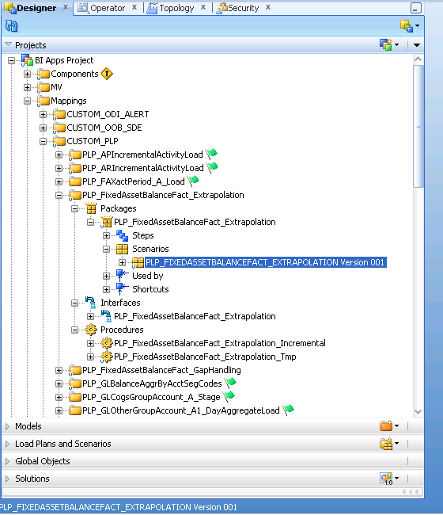

### Note: When re-generating the senario’s , please ignore scenario variables(ie., no need to select all/specific parameters, leave as is.) Just click on OK to complete the scenario re-generation process.

### Verification Checklist

1. Include a subset of test steps that will confirm that the customization has been installed properly.

Verify that the deployment has been completed successfully by following these steps:

After importing the above code into ODI, Check the custom PLP NBV patch code which has below interfaces as shown below.

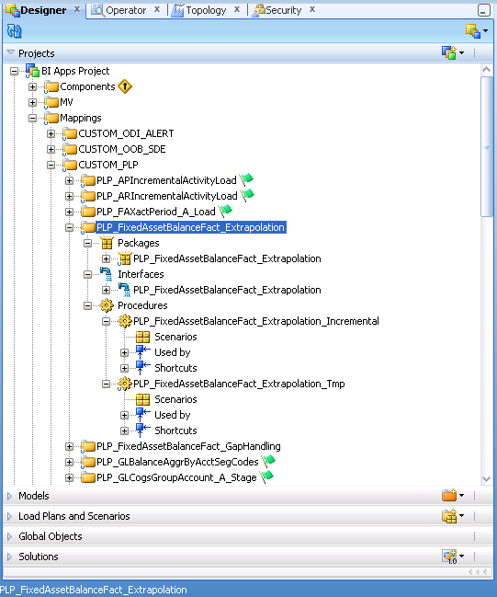

All the components in the ETL_Release_2B should be displayed, please do the following high level components in the ODI Studio, under the Custom_PLP.

|  |
| --- |
| PLP_FixedAssetBalanceFact_Extrapolation |

# Re-Generate Load Plan in the Target instance

* Login to BI Configuration Manager as bi apps administrator. Pick work repository option
* Navigate to Manage Load Plans

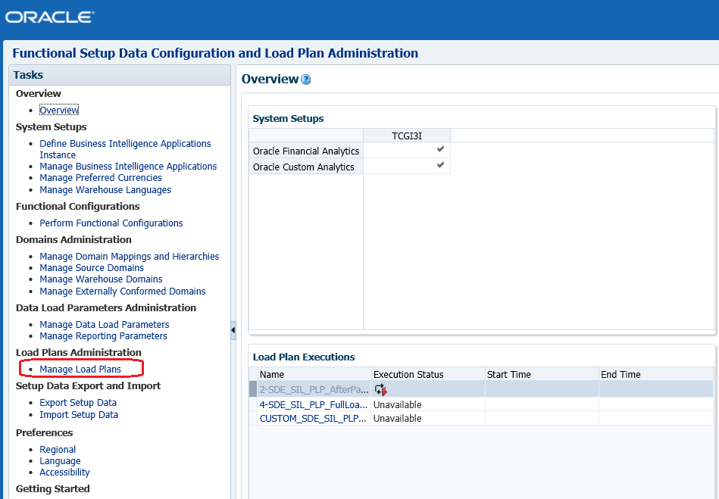

* Select the (Custom + OOB) Load Plan and then hit the Generate Icon.
* Once the generation is successful the status will show as GREEN

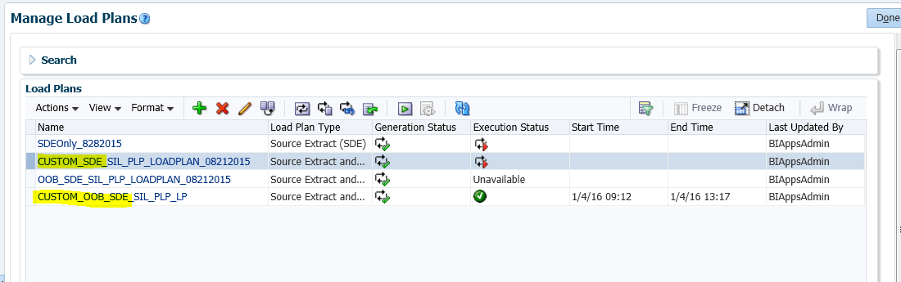

**Verify LP warning Messages:**

Now login into the ODI Studio and open Operator – Find the load plan created

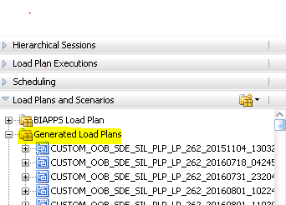

Double click on the new LP and validate as shown below:

e.g.:

Validate the newly generated LP to check if any Release-2 related warnings. If no Release-2 related warnings then we are good

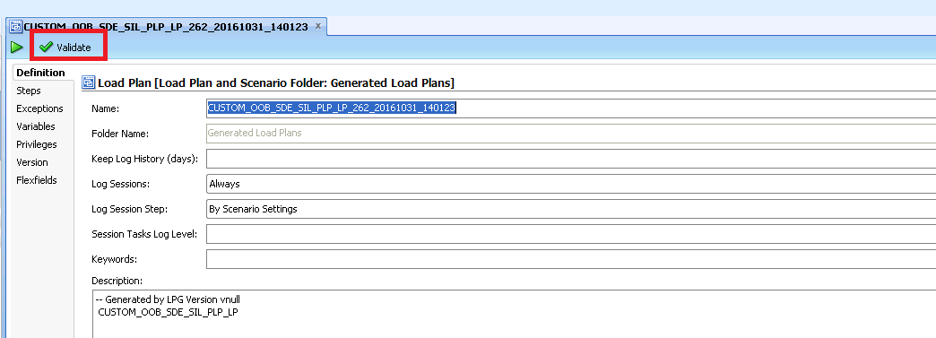

## Execute Load Plan in the Target instance

**IMPORTANT**: Bounce all BI and managed servers and data warehouse database before kicking off the load (OPTIONAL - if already done).

* Flush target database SGA
* Disable the scheduler before executing the load .
* Once the Load plan generated without any warnings/errors, load plan is ready for execution.
* select the Custom Only Load plan and then hit the ‘Execute’ button for Custom FULL LOAD (**no need to ‘Reset the Data warehouse scenario’)**

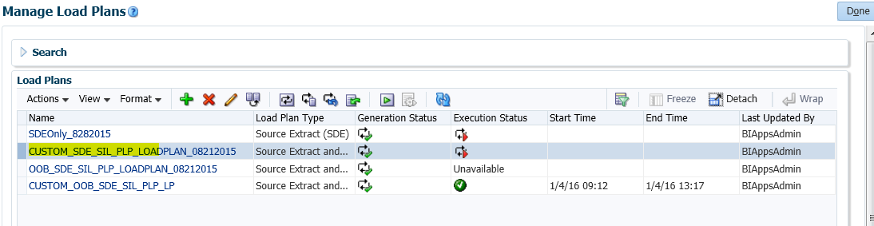

* Once the Load is completed, the status should turn to Green without any warnings.
* Then select the Custom+OOB Load plan and then hit the ‘Execute’ button for the INCREMENTAL Custom+OOB LOAD.

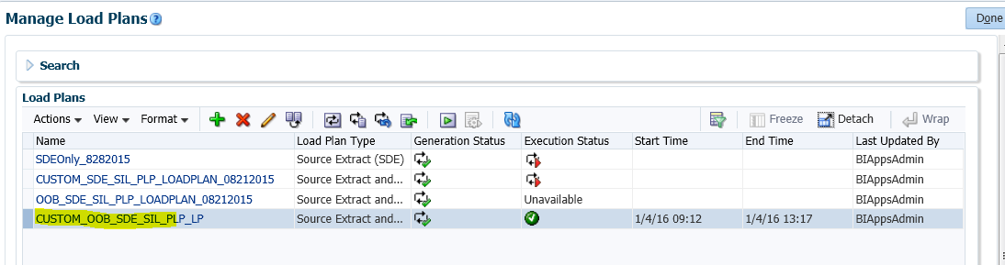

* Once the Load is completed, the status should turn to Green without any warnings.

# Open and Closed Issues

1. Add open issues that you identify while writing or reviewing this document to the open issues section. As you resolve issues, move them to the closed issues section and keep the issue ID the same. Include an explanation of the resolution.  
     
   When this work product is complete, any open issues should be transferred to the project- or process-level Issue Log (Manage focus area) and managed using a project level Issue Form (Manage focus area). In addition, the open items should remain in the open issues section of this work product, but flagged in the resolution column as being transferred.

## Open Issues

| ID | Issue | Resolution | Responsibility | Target Date | Impact Date |
| --- | --- | --- | --- | --- | --- |
|  |  |  |  |  |  |
|  |  |  |  |  |  |
|  |  |  |  |  |  |
|  |  |  |  |  |  |

## Closed Issues

| ID | Issue | Resolution | Responsibility | Target Date | Impact Date |
| --- | --- | --- | --- | --- | --- |
|  |  |  |  |  |  |
|  |  |  |  |  |  |
|  |  |  |  |  |  |
|  |  |  |  |  |  |